
Eclipse Identity Recognition Corporation
1154 60th Street
Brooklyn, NY 11219

TokenPointIR

Guide

January 12, 2012
for Version 2.00E

Copyright (c) 2012, Eclipse Identity Recognition Corporation (EclipseIR). All rights reserved worldwide. Eclipse Identity Recognition Corporation, EclipseIR, INDIface, and their respective logos are trademarks of Eclipse Identity Recognition Corporation. This document is a CONFIDENTIAL TRADE SECRET of Eclipse Identity Recognition Corporation; it may not be copied, reproduced, transmitted, or otherwise shared except under the terms of a non-disclosure or other agreement with EclipseIR.

Background

Eclipse Identity Recognition Corporation™ provides Personal Identity Recognition via its face-based analytics known as INDIface™. It is used to detect faces and facial features and then generate face templates for searching and matching. In addition, the INDIface analytics can also determine skin tone, upper and lower clothes color, and an estimated height of a person. The INDIbase system provides for the enrollment, storage, management, retrieval, and matching of INDIface templates. INDIbase will also manage facial and other images as well as personal identification and characteristic data.


TokenPointIR™ is an application to demonstrate the capability of INDIface to authenticate a security token assigned to a person by capturing multiple images of the face of the person presenting the token. It simulates the presentation of a token and takes video frames from an attached IP camera, collects enough face images to confirm or reject the identity. Or, if after a selectable number of frames or seconds, a determination has not been made, allows an operator to manualy confirm or reject the identity.

Updates

v2.00E 01/12/2012
Set default MinConsistency to 400
Connected Cancel buttons in Enroll modes and during Authentication
Added Quit button
Added application icon and version resources
Renamed to TokenPointIR

Known Issues
AddEnroll creates a new person-BAAD! Probably related: On PersonResult, PersonId does not exist.

The gallery interface is quirky at best and downright broken at worst—when it causes a OS exception. I'm working on a couple of new architectures.

The Cancel button isn't connected to anything yet.
When gathering faces you should be able to exclude a face (from the top right) from consideration by right clicking on it. I haven't tested that yet.

Add and New buttons not always disabled when they should be after canceling.

Plan to accept text tokens.

Automatically initiate AddEnroll upon manual, and especially, override confirm.

Configuration screen.

Better handling of temporary directories and log files.

Installation

DownFTP the contents of the T&A directory from the EIRC Products FTP site to W:/here/ever/you/like. It expects the TokenAuth and INDIface subdirectories to be in parallel.
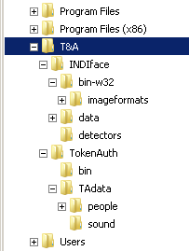
Specify the URL for your camera in the Windows registry at HKCU/Software/EclipseIR/TokenAuth/GatherDf/Input/URL.
For now, also set EclipseIR/TokenAuth/GatherDf/Generate/MinConsistency=400.

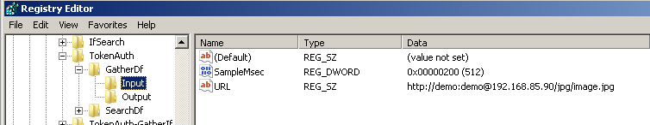
You may want to create a desktop shortcut to ./TokenAuth/bin/TokenAuth.exe.
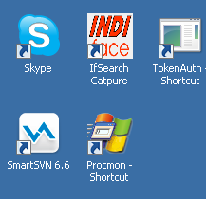

Getting Started

Start TokenAuth. After initialization, live video from your IP camera will be displayed in the upper right panel and detected faces will be displayed to its right.

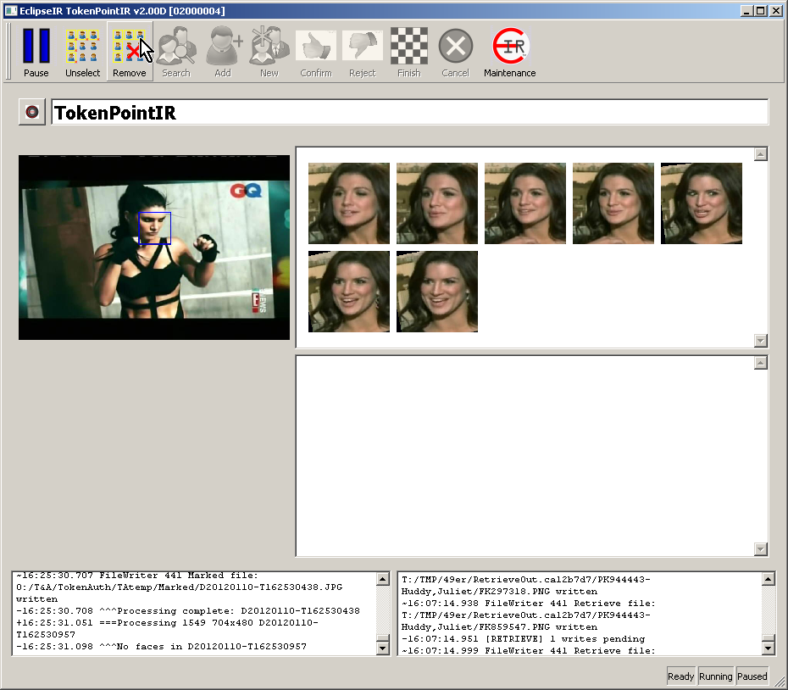

Importing Sample INDIbase

Touch the Maintenance button. You will see a basically empty screen.
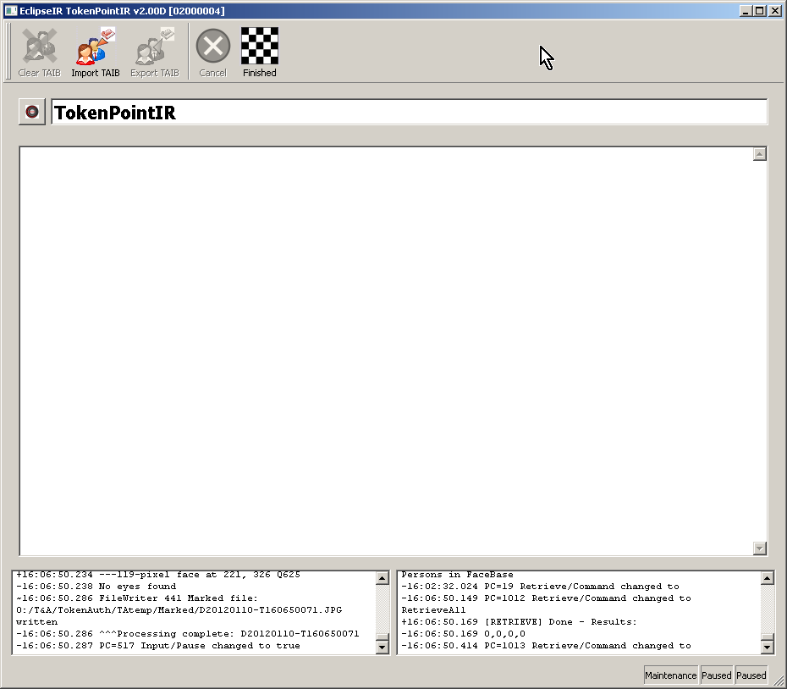
Touch the Import TAIB button. The Id Pane will display the name of each person that is being imported along with a progress bar.

When completed, all of the enrolled faces will be displayed. Take note of the yellow “chip” on the initial face for each person. And touch Finished to return to the “Live” screen.
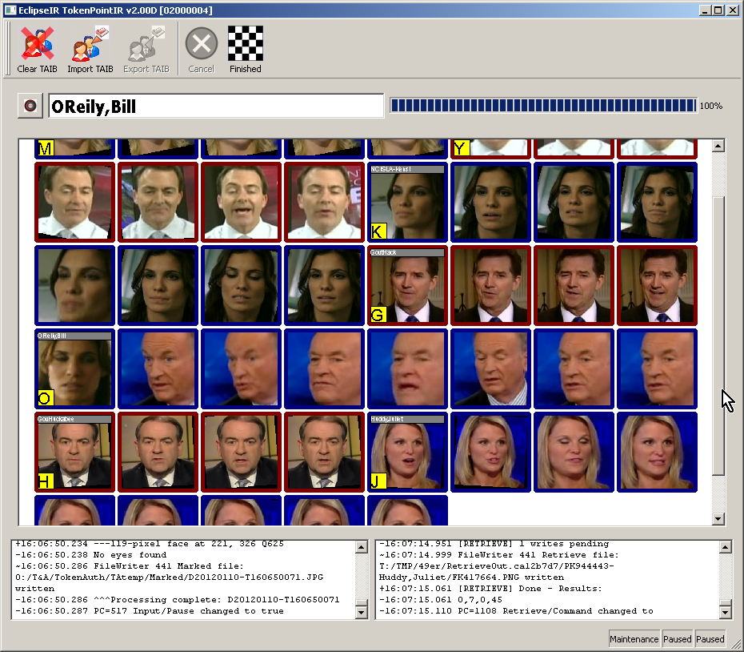

Simulation

To simulate the presentation of a token, you can press one of the keys indicated on the yellow chips in the Maintenance screen. (At the moment, M Y K G O H J) To simulate a random video of that person, press the same key while the Shift key is in effect. They can be pressed in either order, but should be relatively close together in time so the authentication process does not timeout unneccessarliy.

For example pressing [Shift-H] and [h] will produce a result similar to this:
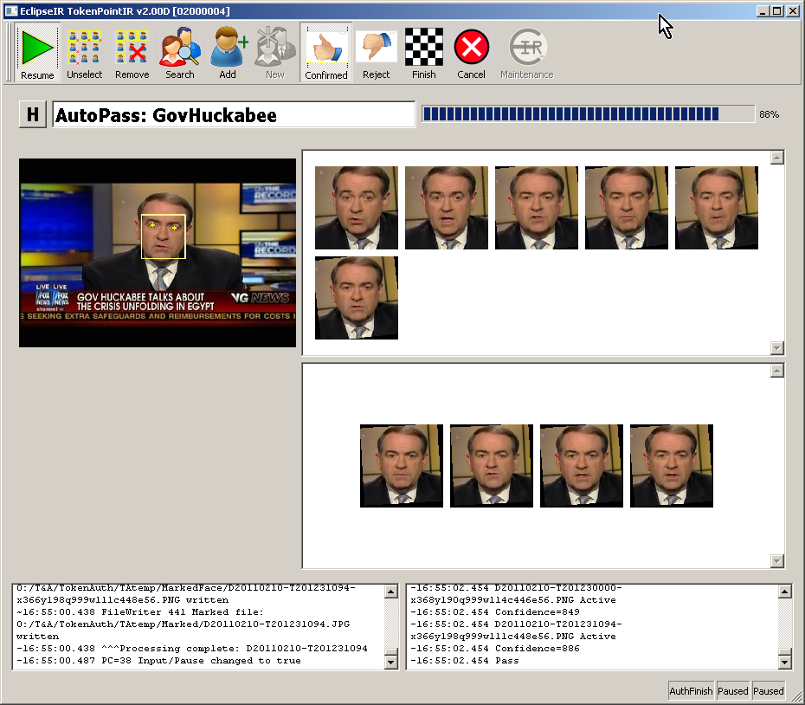
This indicates that Governor Huckabee was confirmed by the six images from (stored, simulared live) video shown in the upper right against his enrolled images shown in the lower right. Touch Finish to arm the system for the next token.

Notes on the Sample INDIbase

The enrollment for [O] is entirely with his nose pointed camera-left. In extreme cases (live images entirely straight forward) this causes an initial rejection. Note the match has been rejected as a 39% match. You can overide the automatic decision by touching Confirm and can further train the database by adding additional faces to his enrollment.
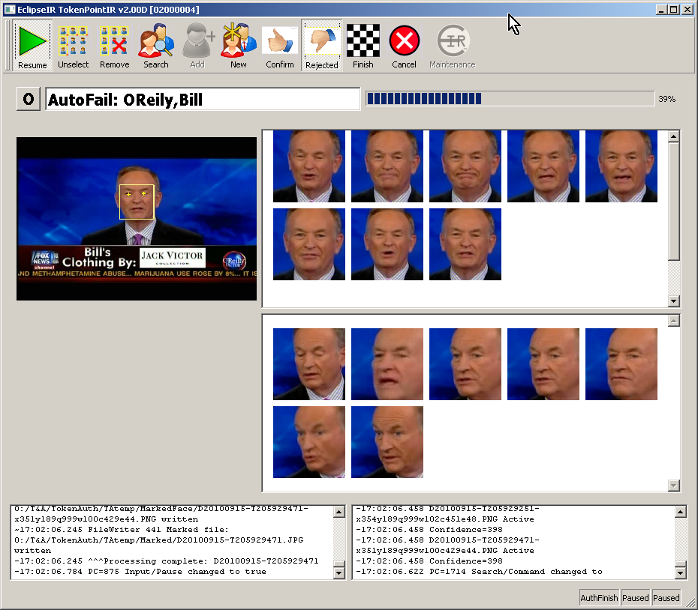
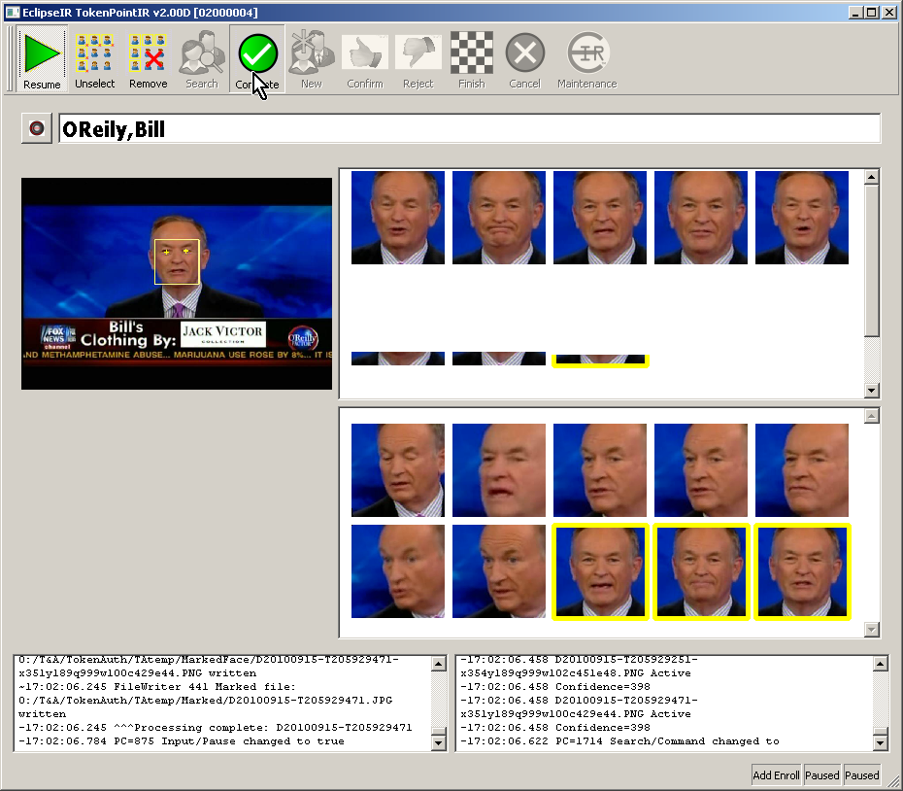
Select a few images (often the first, last, and a couple in the middle) by touching the faces in the upper right pane. Then touch Add [to enrollment] button; the selected images will transfer to the lower right pane. Touch the Complete button--the back side of the Add button—to complete adding to the enrollment for the displayed person.

The [M] and [J] infoblondes have very similar faces. Often authorization for these two is difficult. Pressing [M][m] or [J][j] are very sucessful often 98% or better, but pressing [M][j] or [J][m] will produce results in the 80% range. Below 85% requires manual confirmation, but over 85% will produce an inappropriate automatic confirmation.

From Wikipedia, the free encyclopedia: A security token (or sometimes a hardware token, hardbad token, authentication token, USB token, cryptographic token, or key fob) may be a physical device that an authorized user of computer services is given to ease authentication. The term may also refer to software tokens. Security tokens are used to prove one's identity electronically (as in the case of a customer trying to access their bank account). The token is used in addition to or in place of a password to prove that the customer is who they claim to be. The token acts like an electronic key to access something. Some may store cryptographic keys, such as a digital signature, or biometric data, such as fingerprint minutiae. Some designs feature tamper resistant packaging, while others may include small keypads to allow entry of a PIN or a simple button to start a generating routine with some display capability to show a generated key number. Special designs include a USB connector, RFID functions or Bluetooth wireless interface to enable transfer of a generated key number sequence to a client system.
Looking forward to better icons from Mr. Smart.
Note the incorrect face enrolled as Bill O'Reily; that is fixed on the FTP server.
TODO: Configuration screen for the user. Default values can be set in EclipseIR/TokenAuth/SearchDf/Search or live values can be changed in EclipseIR/TokenAuth-SearchIf/Search. Available variables are AuthMinFaces (the minimum number of faces to collect before trying, default 3), AuthMaxFaces (the maximum number of faces gathered before giving up, default 10), AuthPassConfidence (the match confidence that will trigger an automatic pass, default 850 or 85%), AuthTimeout (the number of milliseconds before giving up, default 5000 or 5 seconds), and AuthFailConfidence (the maximum match confidence thatwill trigger an automatic rejection, default 600 or 60%).

